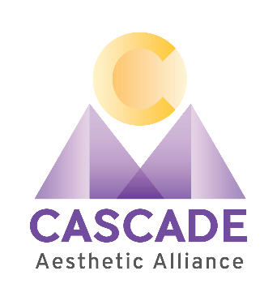

APPLICATION FOR $500 SCHOLARSHIP DATE______________

PERSONAL INFORMATION

NAME_______ _____________________________________________________

MAILING ADDRESS________ _________________________________________

CITY______ ____________________ STATE ___________ ZIP___________

PHONE________________ EMAIL___________________________________________

ESTHETIC SCHOOL YOU WOULD LIKE TO ATTEND:______________________________________

DATE YOU WILL START SCHOOL:_____________________________________________________

You have two options to apply for this scholarship.

Option One: Write : Describe in 500 words, what has led you to esthetics and what is your goal after completion of this program

Option Two: Video Clip: Describe in 3 minutes or less, what has led you to esthetics and what is your goal after completion of this program.

Send your application and entry to Cascade Aesthetic Alliance, mary@cascadeaestheticalliance.org.

Your entry will be evaluated by a team of Cascade members and you will be notified within 30 days.

